**Configuring Application Insights using Azure**

1.Go to the resource and select the Application Insights in the blade navigation menu

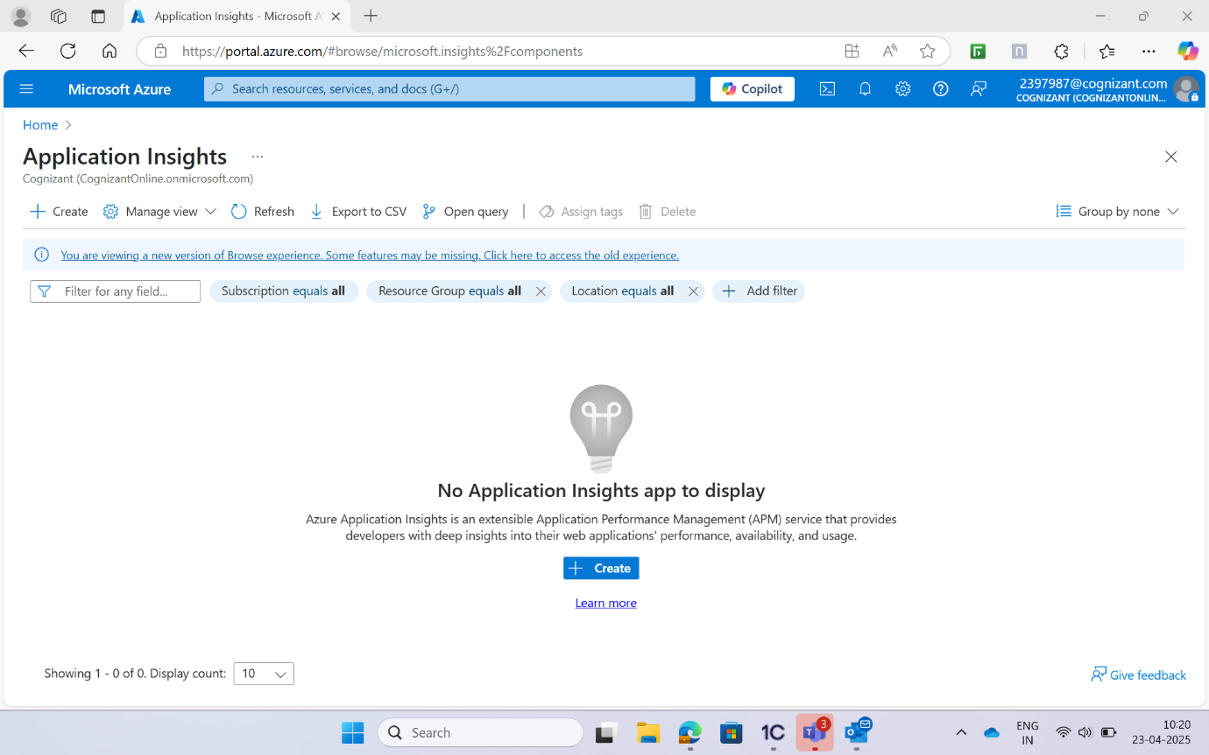

2.configure with the following parameters: • Application Insights: Enable • New resource name: Leave as default (should match the name of the web app) • Location: Leave as default • Collection level: Basic

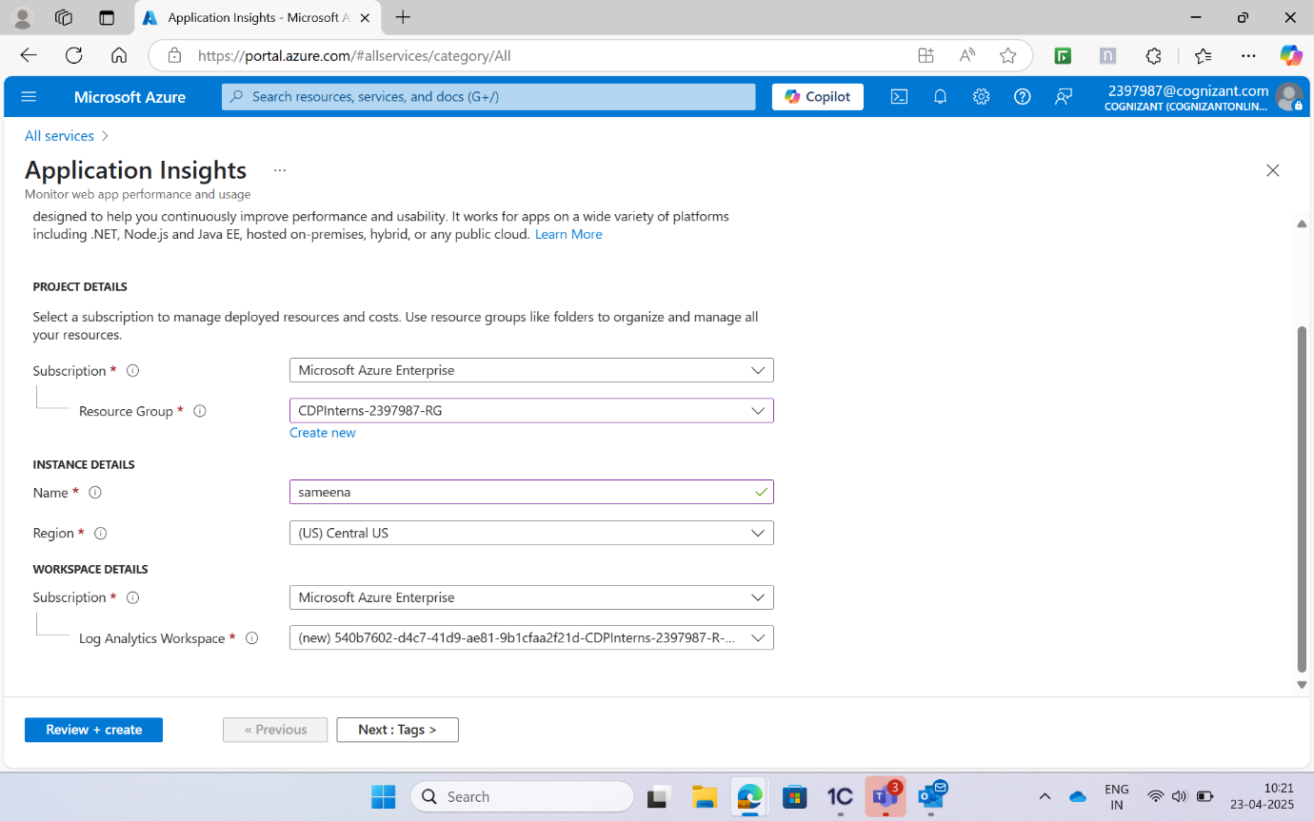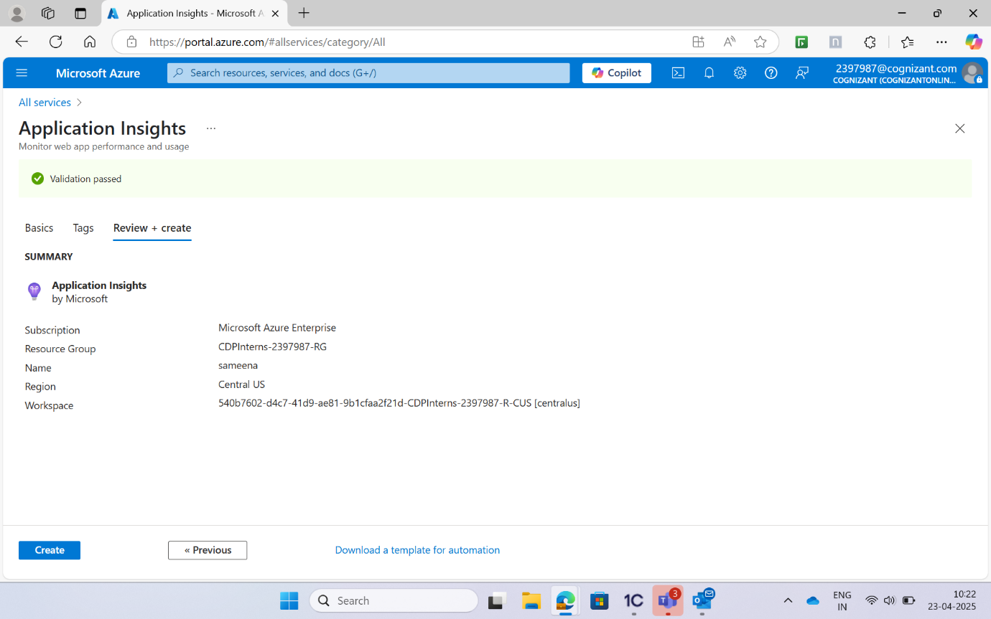

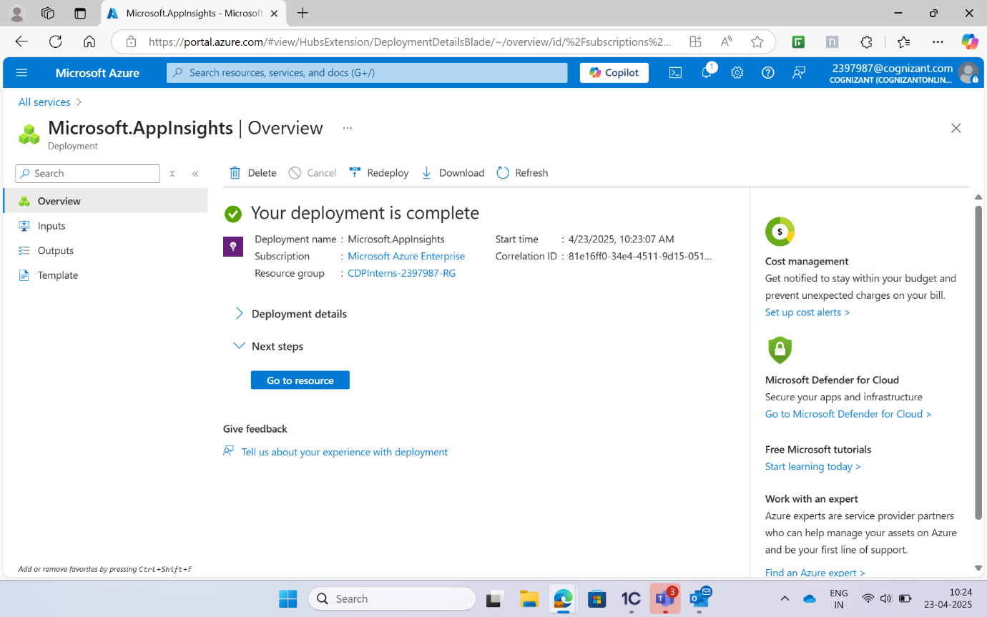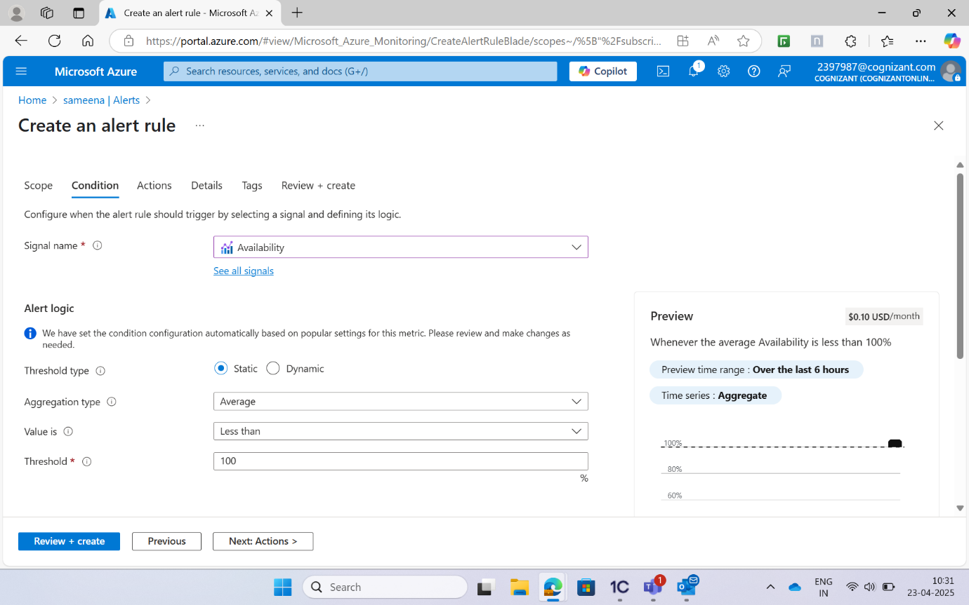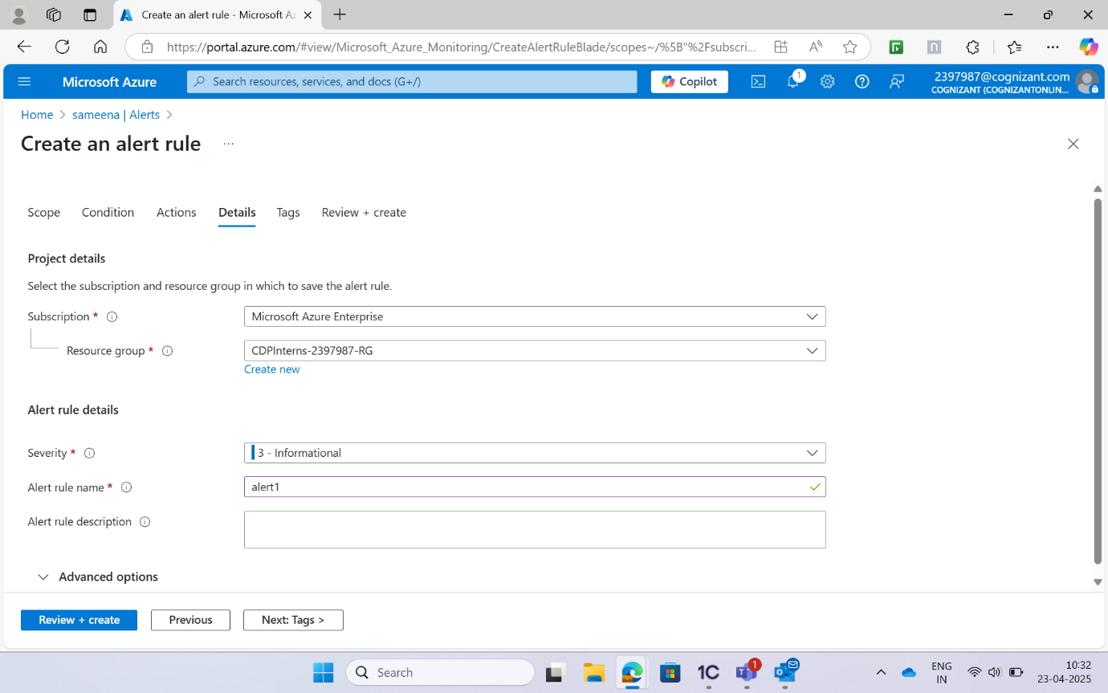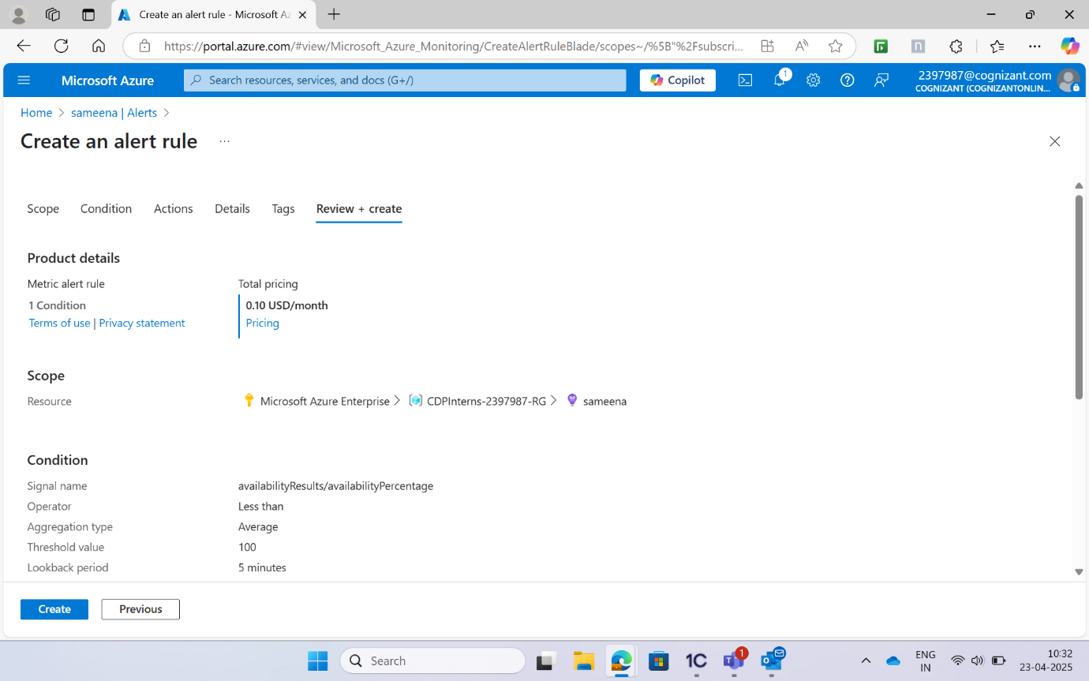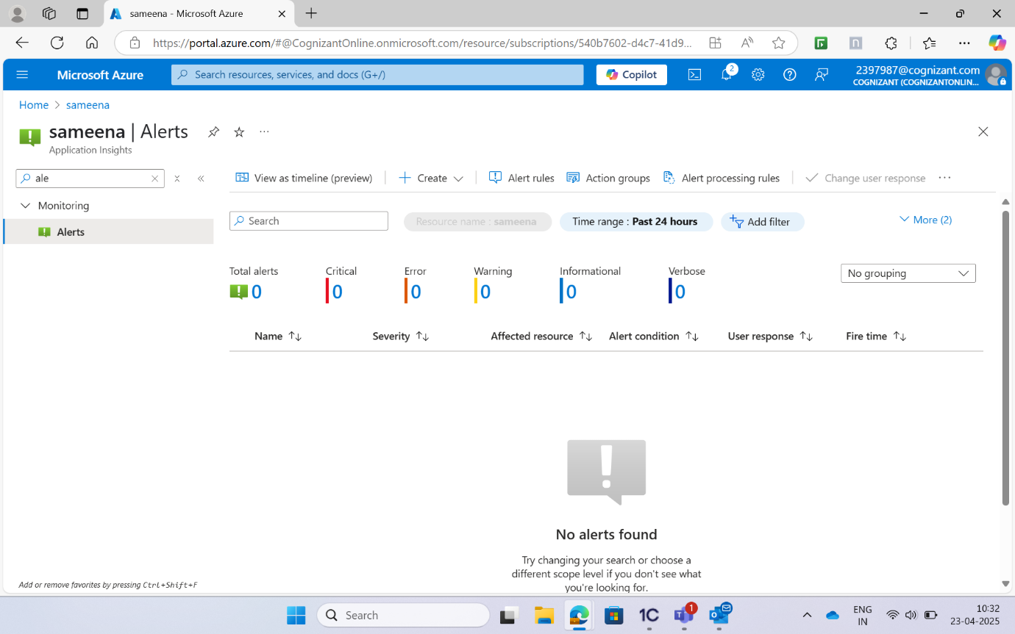

Go to the All resources and select the Application Insights of the WebApp that has been created and go to the Availability under the blade navigation menu and perform the following steps: • +Add Test • Test name: URL ping1 • Test type: URL ping test • URL: Paste the URL copied from the WebApp 9. Leave all the other parameters with the default values and select Create